Q1:
- Make truth table for :

  - q→(p ~ r) p q
  - p→q q p ~ r (4 Marks)

Ans:

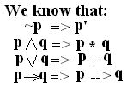
(i)
p | q | r | r’ | p+r’ | (p+r’)*p | (p+r’)*p+q | q→(p+r’)*p+q
T | T | T | F | T | T | T | T
T | T | F | T | T | T | T | T
T | F | T | F | T | T | T | T
T | F | F | T | T | T | T | T
F | T | T | F | F | F | T | T
F | T | F | T | T | F | T | T
F | F | T | F | F | F | F | T
F | F | F | T | T | F | F | T
(ii)
p | q | r | r’ | q*p | q*p+r’ | q+q*p+r’ | p→ q+q*p+r’
T | T | T | F | T | T | T | T
T | T | F | T | T | T | T | T
T | F | T | F | F | F | F | F
T | F | F | T | F | T | T | T
F | T | T | F | F | F | T | T
F | T | F | T | F | T | T | T
F | F | T | F | F | F | F | T
F | F | F | T | F | T | T | T

- Explain with example the use of conditional connectives in the forming of prepositions. (2 Marks)

Ans:

Conditional Connectives:
Give any two preposition p and q, we denote the statement ‘If p, then q’ by p –> q. we also call p the hypothesis and q the conclusion. Further a statement of the form p –>q is called a conditional statement or a conditional preposition.

Example:
The conditional proposition If m is in Z, then m belongs to Q’. The hypothesis is ‘m belong Z’ and the conclusion is ‘m belong Q’.
Mathematically, we can write this statement as
m belong Z –> m belong Q.

- Write down suitable mathematical statement that can be represented by the following symbolic properties.

  - (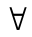x) ( y) P

ii) (x) (y) (z) P (4 Marks)

Ans:

Suitable mathematical statement that can be represented by following symbolic properties.

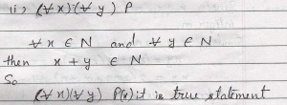
Q2:
a) Explain different methods of proof with the help of one example of each. (6 Marks)

Ans:

Different Methods Of Proof:
1. Direct Proof
A direct proof of p=>q is a logically valid argument that begins with the assumptions that p is true and, in one or more applications of the law of detachment, concludes that q must be true.
So, to construct a direct proof of p=>q, we start by assuming that p is true. then, in one or more steps of the form p=>q1, q1=>q2,….qn=>q, we conclude that q is true.
Example: The product of two odd integers is odd.
Solution: Let two odd integers x and y.
So the hypothesis, p: x and y are odd.
The conclusion we want to reach q: xy is odd
we will first proof that p=>q.
since x=2m+1 for some integers m.
similarly, y=2n+1 for some integers n.
then xy=(2m+1)(2n+1) = 2(2mn+m+n)+1
therefor xy is odd.
So, we have since that p=>q.
2. Indirect Proofs
We shall consider two roundabout method for proving p=>q.
Proof by contra positive: In the first method, we we use the fact that the proposition p=>q is logically equivalent to its contra positive (~q => ~p) ,
What we do to prove p => q in this method is to assume that q is false and then show that p is false.
Example: Prove that ‘If x, y belong Z such that xy is odd then both x and y are odd’.
Solution: p: xy is odd.
q: both x and y is odd, then
~p: xy is even.
~q:both x and y is even.
We want to prove p=>q, by proving that ~q=>~p. So we start by assuming that ~q is true, we suppose that x is even.
The x = 2n for some n belong N
therefor xy=2ny
therefor xy is even, that is ~p is true.
So ~q=>~p therefor, p=>q.
Proof by contradiction: In this method, we prove q is true, we start by assuming that q is false (~q is true). Then by a logical argument we arrive at a situation where a statement is true as well as false, we reach contradiction r ^ ~r for some statement that is always false. This con only happen when ~q is false also. therefor q must be true. This method is called Proof by contradiction.
Example: If two distinct lines L and L’ intersect , then their intersection consists of exactly one point.
Solution: There is two distinct line L and L’ intersect more then one points. Let us call two of these distinct points A and B. Then , L and L’ contain A and B. this contradicts the axiom from geometry that says ‘Given two distinct points , there is exactly one line containing them.’
Therefor if L and L’ intersect then they must intersect in only one point.
3. Counterexamples
Counterexample to a statement p proves that p is false that is ~p is true.
Example: Proof that For All x belong Z, where x belong Q/N.
Solution: To disproving p <=> q it is enough to proof that p <=> Q is false or q=> p is false.
b) Show whether root 17 is rational or irrational.
(4 Marks)
Ans:

Root17 is irrational, since 17 is a prime.
because Square root of any prime number is irrational.
Proof BY Contradiction,
We begin by assuming that root 17 is rational. This means that there exist positive integers a and b such that root 17 = a/b , where a and b have no common factors.
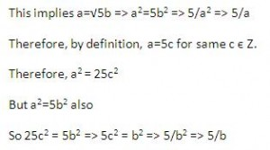
But now we find that 17 divides both a and b, which contradicts our earlier assumption that a and b have no common factor.
Therefor, we conclude that our assumption that root 17 is rational is false, that is root 17 is irrational.
Q3:
a) What is Boolean algebra? Write uses of Boolean algebra. Explain how you can find dual of a theorem about Boolean algebra. (5 Marks)
Ans:
Boolean Algebra:
What allows us to give reply is the concept of Boolean algebras.
It is possible to design an electric / electronic circuit without actually using switches or logic gates and wires.
As before , let the letters p, q, r……… denote statement or propositions. As you may recall, a tautology T is any proposition witch is always true or always false.
T <= S , F <= S
A Boolean algebra B is an algebraic structure which consists of a set X and two specially defined element 0 or 1 which satisfy the following five laws for all x, y, z belong X.
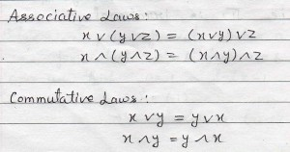
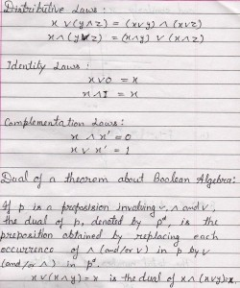

b) If p and q are statements, show whether the statement [(p→q) (~ q)] → (~p) is a tautology or not. (5 Marks)
Ans:
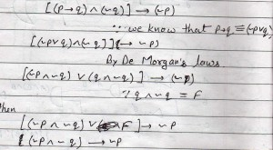
p | q | ~p | ~p | ~p ^ ~q | (~p ^ ~q) –> ~p
T | T | F | F | F | T
T | F | F | T | F | T
F | T | T | F | T | T
F | F | T | T | F | T
There the proposition we a started with is a tautology.
Therefor the statement [(p --> q) ^ (~q)] –> (~p) is a tautology.
Q4:
a) Make logic circuit for the following Boolean expressions:
i). (x.y + z) + (x+z)
ii). x.y′+ y.z′+z′x′ + x .y
(4 Marks)
Ans:
Logic circuit for Boolean expressions:
(i) (x.y + z) + (x+z)
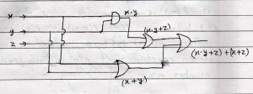
(ii) x.y’+ y.z’+z’x’ + x .y
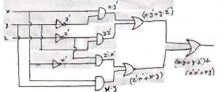
b) Find Boolean expression for the output of the following logic circuit given in the Figure a:

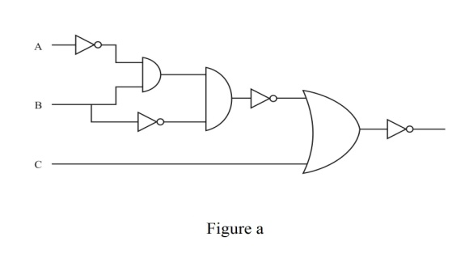
(3 Marks)

Ans:

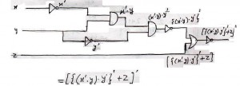
Boolean expressions =
c) Write a superset for the following sets:

A = {1, 2, 3, 4, 9, 19}, B = {1, 2} and C {2, 5, 11}, D = {1, 3, 5}

Also tell whether set B is a subset of set C or not. (3 Marks)

Ans:

Set A is super set of set B because each element of set B is also an element of set A.
Therefor,
Then set B is not subset of set C because each element of set B is not set C.
Therefor,
Q5:
a) Draw a Venn diagram to represent followings:

- (A B) (C~A)
- (AB) (BC)
(4 Marks)
Ans:
Draw a Vann diagram to represent following:
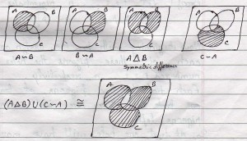
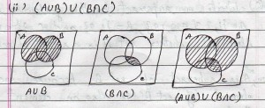
OR
- Venn diagram
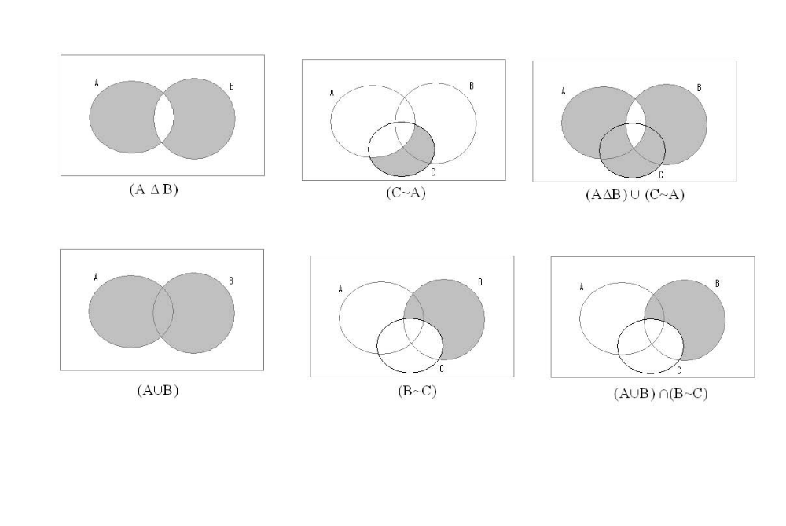
b) Give geometric representation for the following:

- { 3, 1} x R
- {-1, -1) x ( -2, 3)
(4 Marks)
Ans:
Geometric representation:
(i) {3,1} x R => {3} x R and {1} x R
The geometric diagram for {3} x R will be the line parallel to Y axis, x=3.
And similarly x=1, parallel to y axis.
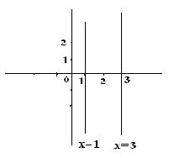
c) What is principle of strong mathematical induction? In which situation this principle is used.
(2 Marks)
Ans:
Principle of Strong Mathematical Induction:
Let P(n) be a predicate that involves a natural number n. Suppose we can show that
(i) p(m) is true for some m belong N
(ii) whenever p(m) ,p(m+1),………,p(k) are true,
That p(k+1) is true, where k>=m we can conclude that p(n) is true for all natural number n>=m.
In the induction step we are making more assumption. That p(n) is true for every n lying between m and k , not just that p(k) is true.
To use the strong form of the PMI, we take m=1. We have seen that p(1) is true We also need to see if p(2) is true.
Then next step,
For an arbitrary k>=2 , We assume that p(n) is true for every n such that,
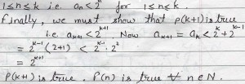
Q6:
- What is permutation? Explain circular permutation with example. (5 Marks)

Ans:
- Permutation : An arrangement of a set of objects in a given order.

Circular permutations
There are two cases of circular-permutations:-
(a) If clockwise and anti clock-wise orders are different, then total number of circular-permutations is given by (n-1)!
(b) If clock-wise and anti-clock-wise orders are taken as not different, then total number of circular-permutations is given by (n-1)!/2!
Proof(a):
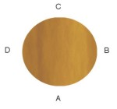
(a) Let’s consider that 4 persons A,B,C, and D are sitting around a round table
Shifting A, B, C, D, one position in anticlock-wise direction, we get the following agreements:-
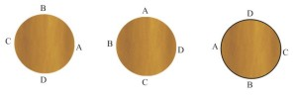
Thus, we use that if 4 persons are sitting at a round table, then they can be shifted four times, but these four arrangements will be the same, because the sequence of A, B, C, D, is same. But if A, B, C, D, are sitting in a row, and they are shifted, then the four linear-arrangement will be different.
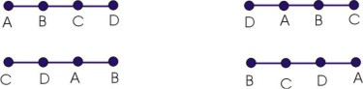
Hence if we have ‘4’ things, then for each circular-arrangement number of linear-arrangements =4
Similarly, if we have ‘n’ things, then for each circular – agreement, number of linear – arrangement = n.
Let the total circular arrangement = p
Total number of linear–arrangements = n.p
Total number of linear–arrangements
= n. (number of circular-arrangements)
Or Number of circular-arrangements = 1 (number of linear arrangements)
n = 1( n!)/n
circular permutation = (n-1)!
Proof (b) When clock-wise and anti-clock wise arrangements are not different, then observation can be made from both sides, and this will be the same. Here two permutations will be counted as one. So total permutations will be half, hence in this case.
Circular–permutations = (n-1)!/2
Note: Number of circular-permutations of ‘n’ different things taken ‘r’ at a time:-
(a) If clock-wise and anti-clockwise orders are taken as different, then total number of circular-permutations = ^{n}P_{r} /r
(b) If clock-wise and anti-clockwise orders are taken as not different, then total number of circular – permutation = ^{n}P_{r}/2r
Example: How many necklace of 12 beads each can be made from 18 beads of different colours?
Ans. Here clock-wise and anti-clockwise arrangement s are same.
Hence total number of circular–permutations: ¹⁸P₁₂/2x12
= 18!/(6 x 24)
OR

Permutation:
Suppose we have 15 Books that we want to arrange on a sheaf. How many ways are these of doing it? Using the multiplication principle you would say
15*14*13*……*2*1=15!
Each of these arrangements of the books.
Definition:
An arrangement of a set of n objects in a given order is called a permutation of the objects
An ordered arrangement of the n objects, taking r at a time(r<=n) is called a permutation of the n objects taking r at a time.
The total number of permutation is P(n,r)=n!/(n-r)!
Circular permutation:
Consider an arrangement of 4 objects, a, b, c and d. We observe the objects in the clockwise direction. On the Circumference these is no preferred origin and hence the permutation abcd, bcda, cdab, dabc will look exactly alike. So each linear permutation when treated as a circular permutation is repeated 4 times.
Thus, the number of circular permutation of n things taken all at a time , is (n-1)!
Example: In how many distinct may is it possible to seat eight persons at a round table?
Solution: Clearly we need the number of circular permutation of 8 things. Hence the number is 7! = 5040.
b) Find inverse of the following function:

f(x) = 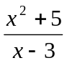 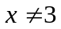 (2 Marks)
Ans:

- Inverse

F(x)=x²+5/x-3 where x not =3

Replacing f(x) by y :
y= x²+5/x-3

by interchanging x and y we get
x= y²+5/y-3

(y-3)x=y²+5
xy-3x=y²+5
y²-xy=-(3x+5)

y(y-x)=-3x-5……………. Eq..1

y=-3x-5/y-x…………….Eq..2

on substituting the values of the right hand side we get

y=-3x-5/-3x-5/(y –x) –x

y=(-3x-5)(y-x)/-3x-5-xy+x²

y=(-3x-5)(y-x)/-3x-5-3x-5………………….Eq….1

y=(-3x-5)(y-x)//2(-3x-5)

y=y-x/2

2y=y-x

y=-x

therefore : inverse is

f⁻¹ (x)=-x
OR

Replace f(x) by y in the equation describing the function.
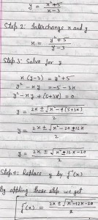
c) What is a function? Explain the uses of the functions. (3 Marks)

Ans:

Function:- The notion of function is a special case of a relation A. Relation may
relate each element of the domain to more than one element of the range. But the
function relates each element of the domain to one and only one element of co-domain(range).
In other words function is a single valued association of all the
elements of the domain with element of the co-domain.

Definition:
Let A & B are two non-empty set. Then the function or mapping from A to B is subset
of A x B satisfying the following conditions:
- for all x € (x,y) € f for some y € B
- if (x,y1) € f(x,y2) € f than y1 = y2

Uses:
Functions have wide applications in mathematics as well as computer science. Using
functions, break-even analysis is done.Complex problems can be worked out easily using functions.

OR

Function:
Because functions are used in so many area of mathematics and in so many different ways no single definition of function has been universally adopted some a function is a way to assign to each element of the given set exactly one element of a given set. A function is a special kind of relation. R={(a,b) belong AXB| b is roll number of a} This is a relation between A and B It is a ’special’ relation, ’special’ because to each a belong A there exits ! b such that aRb. we call such a relation a function A to B .
Definition:
1. A function from a non empty set A to a non -empty set B is a subset R of AXB such that for each a belong A there exits a unique b belong B such that (a,b) belong R.
2. Let A and B be non empty sets. A function f from A to B is a roll that assign to each element x in A exactly one element y is B.
f:A –> B (f is a function from A to B).
Example: If A={1,2,3,4} , B={1,8,27,64,125} and the rule of f assign to each number in A its cube. then f is a function of f is A, its co domain is B and its range is {1,8,27,64,125}.
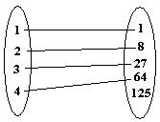
Q7:
a) How many 4 digits number can be formed from 6 digits 1, 2, 3, 4, 5 ,6 if repetitions are not allowed. How many of these numbers are less than 4000? How many are odd?
(5 Marks)

Ans:

Without Repetition, Total number can be formed
= P(6,4)
= 6!/2!
= 360 ways
For the number to be less then 4000, the leftmost digit can only be 1,2 or 3.
So the total number of numbers less the 4000 will be:
= 3*P(5,3)
= 180 ways
similarly, The total number of odd numbers
= 4 * P(5,3)
= 240 ways
OR
Without repetitions , the number is P(6,4).

For the number to be less than 4000, the left most digit can be only 2 or 3.

The rest of the digit can be filled in P(5,3) ways.

Therefore the total number of numbers less than 4000 will be 2P (5, 3) .

Similarly, the total number of odd numbers will be 3P (5, 3).

b) What is pigeonhole principle? Explain the applications of pigeonhole principle with example?

(5 Marks)
Ans:

Pigeonhole Principle:
the general rule states when there are k pigeonholes and there are k+1 mails, then they will be 1 pigeonhole with at least 2 mails. A more advanced version of the principle will be the following: If mn + 1 pigeons are placed in n pigeonholes, then there will be at least one pigeonhole with m + 1 or more pigeons in it.
The Pigeonhole Principle sounds trivial but its uses are deceiving astonishing! Thus, in our project, we aim to learn and explore more about the Pigeonhole Principle and illustrate its numerous interesting applications in our daily life.
or
If m pigeons occupy n pigeonholes, Where m>n, then there is at least one pigeonhole with two or more pigeons in it.
Example:
Pigeonhole Principle and the Birthday problem
We have always heard of people saying that in a large group of people, it is not difficult to find two persons with their birthday on the same month. For instance, 13 people are involved in a survey to determine the month of their birthday. As we all know, there are 12 months in a year, thus, even if the first 12 people have their birthday from the month of January to the month of December, the 13th person has to have his birthday in any of the month of January to December as well. Thus, we are right to say that there are at least 2 people who have their birthday falling in the same month.
In fact, we can view the problem as there are 12 pigeonholes (months of the year) with 13 pigeons (the 13 persons). Of course, by the Pigeonhole Principle, there will be at least one pigeonhole with 2 or more pigeons!
OR

Let there be n boxes and (n + 1) objects. Then, under any assignment of objects to
the boxes, there will always be a box with more than one object in it.
It is one of the counting principles, whose generalization is:

If nm+1 objects are distributed among m boxes, then at least one box will contain
More than n objects.

We shall have a look at some of the applications of the above two statements.

(1) If 8 people are chosen randomly from a group, atleast 2 of them will have been
born on the same week day. (7 days in a week).

(2) In any group of 13 people, atleast two are born in the same month, (12 months
of a year).

(3) In a group of 30 people, we can always find 5 people who were born on the same
day of the week.

(since [30/7]+1=5)

Q8:
a) How many different 5 persons committees can be formed each containing at least two women and at least one man from a set of 10 women and 15 men. (3 Marks)
Ans:

4 women and 1 man in C(10,4) x C(15,1) = 3150 ways
3 " 2 " in C(10,3) x C(15,2) = 12600 "
2 " 3 " in C(10,2) x C(15,3) = 20475 "
----------
Total = 36225 <---------

b) How many ways are there to distribute or district object into 12 distinct boxes with
- At least three empty box.
- No Empty box. (4 Marks)
Ans:

i)
This is the same as at most 9 occupied boxes.
We can choose the 9 boxes in C(12,9) = 220 ways .
To distribute the 14 distinct objects into 9 boxes with empty boxes
allowed the number of ways = 9^14
Required answer = 220 x 9^14
= 5.032894 x 10^15
ii)
For this we require the coefficient of x^14/14! in the expansion of
[e^x - 1]^12 = e^12x - C(12,1)e^11x + C(12,2)e^10x - ... C(12,12) and taking out the terms in x^14/14! we get
(x^14/14!).[12^14 - C(12,1)11^14 + C(12,2)10^14 - C(12,3)9^14
+ C(12,4)8^14 - C(12,5)7^14 + C(12,6)6^14 - C(12,7)5^14
+ C(12,8)4^14 - C(12,9)3^14 + C(12,10)2^14 - C(12,11)]
(x^14/14!).[1.612798387 x 10^12]
So there are 1.6128 x 10^12 ways if no empty boxes allowed.

c) In a twenty question true false examination a student must achieve eight correct answers to pass. If student answer randomly what is the probability that student will fail. (3 Marks)

Ans:

Lets x denote the number of wrong answers. Then x follows the binomial distribution with n=20 and p=1/2

Therefore q= 1 - ½ = ½

Then the pdf of x is,

p(x) = nc_{x} p^{x} q^{n-x} , x=0,1,2,............,20

The required probability is, p(x<8)

P(x<8)=P(0)+p(1)+..........+p(7)

=20c₀(1/2)⁰ (1/2)²⁰⁻⁰ +20c₁ , (1/2)¹ (1/2)²⁰⁻¹ +20c₂ (1/2)² (1/2)²⁰⁻² + 20c₃ (1/2)³ (1/2)²⁰⁻³+ 20c₄ , (1/2)⁴ (1/2)²⁰⁻⁴+ 20c₅ , (1/2)⁵ (1/2)²⁰⁻⁵+ 20c₆ , (1/2)⁶ (1/2)²⁰⁻⁶+ 20c₇ , (1/2)⁷ (1/2)²⁰⁻⁷

=(1/2)²⁰(1+20+(20*19/2*1)+(20*19*18/3*2*1)+(20*19*18*17/4*3*2*1)+(20*19*18*17*16/5*4*3*2*1)+(20*19*18*17*16*15/6*5*4*3*2*1)+(20*19*18*17*16*15*14/7*6*5*4*3*2*1)

= (1/2)²⁰(21+190+1140+4845+15504+38760+77520)

= 137980/1048576

= 0.1316

